Zoning and Bylaw
This is the ontological representation of Toronto’s zoning by-law designations and zoning-type constraints, capturing how specific areas of land are regulated under Toronto Zoning By-law 569-2013. Individual zoning regulations are represented as instances of the hp:Regulation class (e.g., tor:zoning_reg_{OBJECTID}) and are linked to the regulated land area (e.g., tor:area_{OBJECTID}) using hp:definedFor. Each land area is represented as an hp:AdministrativeArea with a geospatial location (loc:hasLocation) and boundary geometry expressed as WKT (geo:asWKT).
To represent zoning classification, each regulation designates one or more zoning types using hp:designatesZoningType, with zoning types represented as instances such as tor:zone_{GEN_ZONE}, tor:zone_{ZN_ZONE}, and tor:zone_{ZN_STRING}. These are related through hp:subZoningType to capture the hierarchy from broader zone categories down to the fully specified zone label. Where applicable, zoning exceptions and holding provisions are also represented as additional regulatory structures linked to the relevant zone types.
To represent the built-form and dwelling unit constraints defined by the zoning by-law (for example, minimum frontage, lot area, height limits, and maximum units), the mapping creates zoning-type–specific regulation constraint instances (e.g., tor:{ZN_STRING}_regulation_constraints) and links them to the relevant zoning type using opr:forZoningType. Quantitative constraints are expressed through ISO measurement structure (i72:hasValue, i72:hasNumericalValue, i72:hasUnit) so units and values are explicit and machine-interpretable.
This section summarizes how the Toronto zoning by-law dataset (zoning areas, zone labels, and regulation attributes) and the by-law text section references are mapped into the City Digital Twin ontology.

The following is a list of namespace prefixes used in the mappings and ontology definitions that follow:
- bylaw: https://standards.iso.org/iso-iec/5087/-2/ed-1/en/ontology/Bylaw/
- genprop: https://standards.iso.org/iso-iec/5087/-1/ed-1/en/ontology/GenericProperties/
- geo: http://www.opengis.net/ont/geosparql#
- hp: http://ontology.eil.utoronto.ca/HPCDM/
- i72: http://ontology.eil.utoronto.ca/ISO21972/iso21972#
- loc: https://standards.iso.org/iso-iec/5087/-1/ed-1/en/ontology/SpatialLoc/
- mer: https://standards.iso.org/iso-iec/5087/-1/ed-1/en/ontology/Mereology/
opr: http://www.theworldavatar.com/ontology/ontoplanningregulation/OntoPlanningRegulation.owl#
- rdfs: http://www.w3.org/2000/01/rdf-schema#
- rdf: http://www.w3.org/1999/02/22-rdf-syntax-ns#
- tor: http://ontology.eil.utoronto.ca/Toronto/Toronto#
- xsd: http://www.w3.org/2001/XMLSchema#

This dataset defines zones with different land use regulations, along with specialized limitations on lot dimensions such as frontage and land area, and development density. Mappings from the dataset’s fields are grouped into the following categories: (1) definition of bylaw references, (2) identification of applicable zoning types, and (3) definition of the zoning type.
The fields identified in Table 1 capture different parts of the bylaw that are referenced by the dataset. In particular, the section and chapter identify the relevant parts for the identified zoning type. These references are useful for referencing the relevant parts of a document for a restriction.

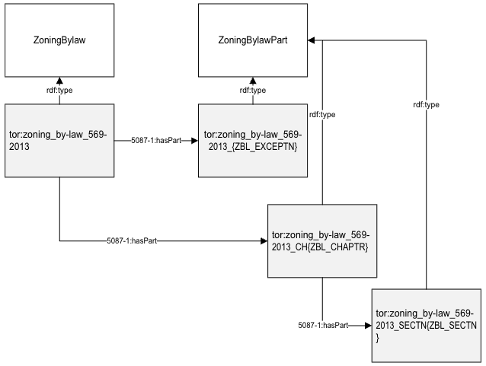
Figure 1: Diagram of bylaw reference mapping result

- ZN_STATUS = (Status of the Zone, primarily indicating whether the lands have been incorporated into By-law 569-2013 or not.) [0-4 and 6 = In the By-law. 5 = Not Part of Zoning By-law 569-2013]
- Used as a filter; map as follows if {ZN_STATUS} != 5
Table 1: Mapping bylaw references from Toronto "Zone Categories" data
"Zone Categories" Field | Mapping to HPCDM
 | Subject | Property | Object | Notes
 | tor:zoning_by-law_569-2013 | rdf:type | hp:ZoningBylaw
 | tor:zoning_by-law_569-2013 | bylaw:legislationIdentifier | "ZONING_BY-LAW_569-2013"
ZBL_EXCPTN = (By-law text section number) | tor:zoning_by-law_569-2013 | mer:hasProperPart | tor:zoning_by-law_569-2013_{ZBL_EXCEPTN}
 | tor:zoning_by-law_569-2013_{ZBL_EXCEPTN} | rdf:type | hp:ZoiningBylawPart
 | tor:zoning_by-law_569-2013_{ZBL_EXCEPTN} | genprop:hasIdentifier | {ZBL_EXCPTN}
ZBL_CHAPTR = (By-law text chapter number) | tor:zoning_by-law_569-2013 | mer:hasProperPart | tor:zoning_by-law_569-2013_CH{ZBL_CHAPTR}
 | tor:zoning_by-law_569-2013_CH{ZBL_CHAPTR} | rdf:type | hp:ZoiningBylawPart
 | tor:zoning_by-law_569-2013_CH{ZBL_CHAPTR} | genprop:hasIdentifier | {ZBL_CHAPTR}
ZBL_SECTN = (By-law text section number) | tor:zoning_by-law_569-2013_CH{ZBL_CHAPTR} | mer:hasProperPart | tor:zoning_by-law_569-2013_SECTN{ZBL_SECTN}
 | tor:zoning_by-law_569-2013_SECTN{ZBL_SECTN} | rdf:type | hp:ZoiningBylawPart
 | tor:zoning_by-law_569-2013_SECTN{ZBL_SECTN} | genprop:hasIdentifier | {ZBL_SECTN}

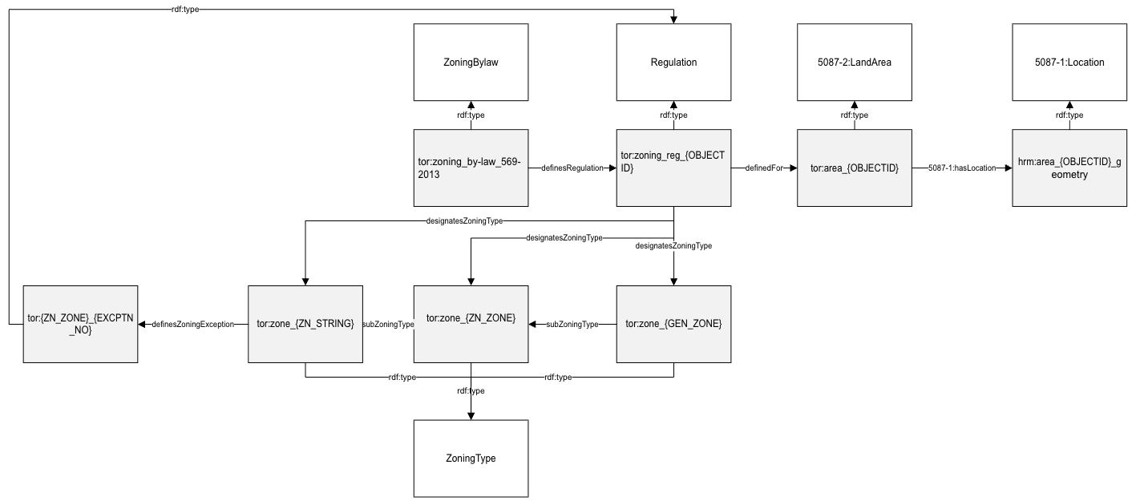
Figure 2: Diagram of zoning type assignment mapping result
Each row in the table associates a zoning type with a particular area. This mapping is outlined in Table 2 Note that each of GEN_ZONE, ZN_ZONE, and ZN_STRING are considered zoning types (at different levels of abstraction) that apply to the same area. A hold (when applied) is interpreted as a different zoning type.
This allows for additional specification on the nature of the hold (e.g., what developments may be permitted/prohibited). On the other hand, exceptions are identified with respect to the ZN_STRING zoning type, as they contribute to its interpretation.
ZN_EXCPTN = (This indicates whether a zone has an Exception.) [Yes (Y) or No (N)]
details of the exception(s) are defined furtherby the bylaw (chapter 900) and should be incorported into the definition of the individual zoning type (ZN_STRING)

Table 2: Mapping zoning type assignments in Toronto
"Zone Categories" Field | Mapping to HPCDM
 | Subject | Property | Object | Notes
OBJECTID = (Unique system identifier) | tor:zoning_by-law_569-2013 | hp:definesRegulation | tor:zoning_reg_{OBJECTID} | #a regulation (part of the bylaw) applies to a specific area (OBJECTID)
 | tor:zoning_reg_{OBJECTID} | rdf:type | hp:Regulation | to add in next iteration
 | tor:zoning_reg_{OBJECTID} | hp:definedIn | tor:zoning_by-law_569-2013
 | tor:zoning_reg_{OBJECTID} | hp:definedFor | tor:area_{OBJECTID}
 | tor:area_{OBJECTID} | rdf:type | hp:AdministrativeArea
 | tor:area_{OBJECTID} | loc:hasLocation | tor:area_{OBJECTID}_geometry
geometry | tor:area_{OBJECTID}_geometry | geo:asWKT | {geometry}
GEN_ZONE = (The land use category of the lands within the zone boundary. Each "zone category" has its own Chapter in the text of By-law 569-2013.) | tor:zoning_reg_{OBJECTID} | hp:designatesZoningType | tor:zone_{GEN_ZONE} | #the regulation defines a zoning type for the area
 | tor:zone_{GEN_ZONE} | hp:subZoningType | tor:zone_{ZN_ZONE}
ZN_ZONE = (The land use category of the lands within the zone boundary. Each "zone category" has its own Chapter in the text of By-law 569-2013.) [Zoned destination of the zone limited by GEN_ZONE. | tor:zoning_reg_{OBJECTID} | hp:designatesZoningType | tor:zone_{ZN_ZONE}
 | tor:zone_{ZN_ZONE} | hp:subZoningType | tor:zone_{ZN_STRING}
 | tor:zone_{ZN_ZONE} | hp:definedIn | tor:zoning_by-law_569-2013_SECTN{ZBL_SECTN}
ZN_STRING = (Complete label of the zone.) | tor:zoning_reg_{OBJECTID} | hp:designatesZoningType | tor:zone_{ZN_STRING} | #values listed in this dataset (and denoted in the ZN_STRING) are defined as part of the zone label, which is essentially a more specific zone (subZoning) for the ZN_ZONE
EXCPTN_NO = (This is the Exception Number for the zone if one exists. The exception number is prefaced by the letter "x" in the zone label. Each zone has its own series of exception numbers, starting at 1, so the exception number must be read in conjunction with the respective zone symbol.) | tor:zone_{ZN_STRING} | hp:definesZoningException | tor:{ZN_ZONE}_{EXCPTN_NO} | #provides a pointer to any exception(s) to the ZN_ZONE regulations applied to this particular zone (ZN_STRING); these are incorporated into the definition of ZN_STRING
ZBL_EXCPTN = (By-law text section number) | tor:{ZN_ZONE}_{EXCPTN_NO} | hp:definedIn | tor:zoning_by-law_569-2013_{ZBL_EXCEPTN}
ZN_HOLDING = (To indicate whether there is a HOLDING status for the zone. The zone label will be prefaced by the letter (H). These are not common, and when used, a Holding Zone is most often applied to specific sites.) [Yes (Y) or No (N)] | tor:holding_reg_{OBJECT ID} | rdf:type | hp:Regulation | #holdings aren't zones and regulations defined within the bylaw (though they are interpreted as zones); they are temporary zones applied to a particular area
 | tor:holding_reg_{OBJECT ID} | hp:definedFor | tor:area_{OBJECTID} | #details of tor:holding_zone are defined furtherby the bylaw
 | tor:holding_reg_{OBJECT ID} | hp:designatesZoningType | tor:holding_zone
HOLDING_ID (Holding Number if it exists.) | tor:holding_reg_{OBJECT ID} | genprop:hasIdentifier | {HOLDING_ID}

The zoning type is defined with the instantiation of any applicable regulations. Here, we outline example mappings for frontage, unit, and density regulations defined for a zoning type. The complete mapping specification is provided in the supplementary file. Table 3 specifies the mapping to capture any frontage regulations for the zoning type. A new Regulation is introduced that applies to the zoning, the regulation specifies a requirement of some Frontage quantity, associated with the “FRONTAGE” value provided in the data. The mapping encodes the intended unit of measure (metres), along with the population that the regulation applies to. In this case, an extension is introduced to define the population of lots in Toronto (TorontoLotPopulation). In practice, the required classes could be identified and defined in a separate extension to the HPCDM, such that they could be referenced directly in any mapping implementation.
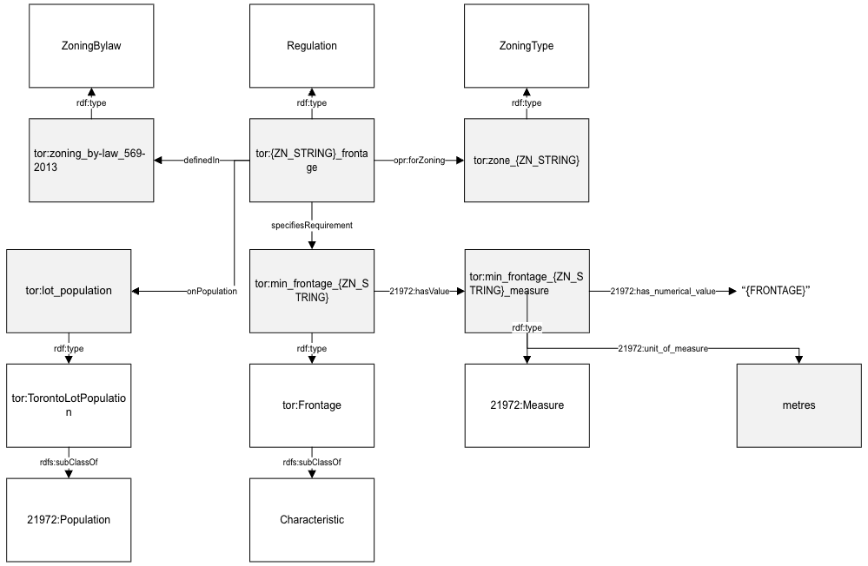
Figure 3: Diagram of Frontage restriction mapping result

Table 3: Mapping the defined Frontage restriction for lots in the zone in Toronto
"Zone Categories" fields | Mapping to HPCDM
 | Subject | Property | Object | Notes
FRONTAGE = (The required minimum Lot Frontage in the zone, and is a numeric value prefaced by the letter "f" within a residential zone label.) [Unit = metres.] | tor:{ZN_STRING}_regulation_constraints | rdf:type | hp:Regulation
 | tor:{ZN_STRING}_regulation_constraints | genprop:hasName | Zone String {ZN_STRING}
 | tor:{ZN_STRING}_regulation_constraints | hp:definedIn | tor:zoning_by-law_569-2013
 | tor:{ZN_STRING}_regulation_constraints | opr:forZoningType | tor:zone_{ZN_STRING}
 | tor:{ZN_STRING}_regulation_constraints | hp:specifiesConstraint | tor:min_frontage_{ZN_STRING}
 | tor:min_frontage_{ZN_STRING} | rdf:type | hp:QuantityRequirement
 | tor:min_frontage_{ZN_STRING} | i72:hasValue | tor:min_frontage_{ZN_STRING}_specification
 | tor:min_frontage_{ZN_STRING}_specification | i72:hasNumericalValue | {FRONTAGE}
 | tor:min_frontage_{ZN_STRING}_specification | i72:hasUnit | hp:metres
 | tor:min_frontage_{ZN_STRING} | hp:specifiesMinimumFor | tor:zone_{ZN_STRING}_lots_min_frontage
 | tor:zone_{ZN_STRING}_lots_min_frontage | rdf:type | hp:Minimum
 | tor:zone_{ZN_STRING}_lots_min_frontage | i72:parameter_of_var | tor:frontage_var
 | tor:zone_{ZN_STRING}_lots_min_frontage | hp:minimumOf | tor:lot_population_in_zone_{ZN_STRING}
 | tor:frontage_var | i72:hasName | "hp:hasFrontage" | #we may actually want to distinguish between the object class too (since a lot could have different frontages, according to different municipalities); I think this is a general requirement - to restrict parameters more precisely - that should be addressed by 21972
 | tor:lot_population_in_zone_{ZN_STRING} | rdf:type | tor:TorontoLotPopulation_Zone{ZN_STRING}

Table 4 specifies the mapping to formalize the maximum number of dwelling units per lot for a particular zone. It is defined as another Regulation that applies to the identified zoning type. The allowance is specified as a quantity that represents the cardinality of the population of dwelling units in a particular lot. The classes used to represent the quantity associated with the regulation (LotNumberOfDwellings and DwellingUnitPopulationInALot) are formulated in the HPCDM. Any characteristics not covered by the model could be defined in an extension.
Table 4: Mapping the maximum number of units per lot in the zone in Toronto
"Zone Categories" fields | Mapping to HPCDM
 | Subject | Property | Object | Notes
UNITS = (The permitted maximum number of Dwelling Units allowed on a lot in the zone, and is a numeric value prefaced by the letter "u" in a residential zone.) | tor:{ZN_STRING}_regulation_constraints | rdf:type | hp:Regulation | Note: no data published
 | tor:{ZN_STRING}_regulation_constraints | hp:definedIn | tor:zoning_by-law_569-2013
 | tor:{ZN_STRING}_regulation_constraints | opr:forZoningType | tor:zone_{ZN_STRING}
 | tor:{ZN_STRING}_regulation_constraints | hp:specifiesConstraint | tor:max_units_{ZN_STRING}
 | tor:max_units_{ZN_STRING} | rdf:type | hp:QuantityAllowance
 | tor:max_units_{ZN_STRING} | i72:hasValue | tor:max_units_{ZN_STRING}_specification
 | tor:max_units_{ZN_STRING}_specification | i72:hasNumericalValue | {UNITS}
 | tor:max_units_{ZN_STRING}_specification | i72:hasUnit | i72:population_cardinality_unit
 | tor:max_units_{ZN_STRING} | hp:specifiesMaximumFor | tor:zone_{ZN_STRING}_lots_max_dwelling
 | tor:zone_{ZN_STRING}_lots_max_dwelling | rdf:type | hp:Maximum
 | tor:zone_{ZN_STRING}_lots_max_dwelling | i72:parameter_of_var | tor:num_dwellings_var
 | tor:zone_{ZN_STRING}_lots_max_dwelling | hp:maximumOf | tor:lot_population_in_zone_{ZN_STRING}
 | tor:num_dwellings_var | i72:hasName | hp:hasNumDwellings | hasNumDwellings originally plannedto be defined in Toronto extension
 | tor:lot_population_in_zone_{ZN_STRING} | rdf:type | tor:TorontoLotPopulation_Zone{ZN_STRING} | #alternatively could define based on the zone area specified by the geometry, e.g. tor:area_{OBJECTID}_geometry
 | tor:TorontoLotPopulation_Zone{ZN_STRING} | rdfs:subClassOf | tor:TorontoLotPopulation
 | tor:TorontoLotPopulation_Zone{ZN_STRING} | i72:located_in | https://www.geonames.org/6167865/toronto.html
 | tor:TorontoLotPopulation_Zone{ZN_STRING} | i72:defined_by only | hp:Lot and hp:hasZone value tor:zone_{ZN_STRING}
 | tor:lot_population | rdf:type | tor:TorontoLotPopulation

Table 5 specifies the mapping to represent a regulation on density in the zone. This regulation specifies a limit on floor space index (FSI) and so is defined as a LotFSI value. LotFSI is defined in the HPCDM as a ratio of gross floor area to lot area.
Table 5: Mapping of density regulation in a zone in Toronto
"Zone Categories" fields | Mapping to HPCDM
 | Subject | Property | Object | Notes
DENSITY = (The permitted maximum Density in the zone by FSI (floor space index), and is a numeric value prefaced by the letter "d" in residential zones.) | tor:{ZN_STRING}_regulation_constraints | rdf:type | hp:Regulation
 | tor:{ZN_STRING}_regulation_constraints | hp:definedIn | tor:zoning_by-law_569-2013
 | tor:{ZN_STRING}_regulation_constraints | opr:forZoningType | tor:zone_{ZN_STRING}
 | tor:{ZN_STRING}_regulation_constraints | hp:specifiesConstraint | tor:max_density_{ZN_STRING}
 | tor:max_density_{ZN_STRING} | rdf:type | hp:QuantityAllowance
 | tor:max_density_{ZN_STRING} | i72:hasValue | tor:max_density_{ZN_STRING}_specification
 | tor:max_density_{ZN_STRING}_specification | i72:hasNumericalValue | {DENSITY}
 | tor:max_density_{ZN_STRING} | hp:specifiesMaximumFor | tor:zone_{ZN_STRING}_lots_max_density
 | tor:zone_{ZN_STRING}_lots_max_density | rdf:type | hp:Maximum
 | tor:zone_{ZN_STRING}_lots_max_density | i72:parameter_of_var | tor:density_var
 | tor:zone_{ZN_STRING}_lots_max_density | hp:maximumOf | tor:lot_population_in_zone_{ZN_STRING}
 | tor:density_var | i72:hasName | "hp:hasFSI"
 | tor:lot_population_in_zone_{ZN_STRING} | rdf:type | tor:TorontoLotPopulation_Zone{ZN_STRING}
 | tor:TorontoLotPopulation_Zone{ZN_STRING} | rdfs:subClassOf | tor:TorontoLotPopulation

Table 6 specifies the mapping to represent Zoning Height Overlay. The same general approach can be defined for any area-based regulations defined independently of zoning types (not incorporated in the zoning area layer)

Table 6: Mapping of Zoning Height Overlay in Toronto
"Zone Categories" Field | Mapping to HPCDM
 | Subject | Property | Object | Notes
_id | tor:height_zone{_id} | rdf:type | hp:Regulation
 | tor:height_zone{_id} | genprop:hasName | "Height Regulation {_id}"
 | tor:zoning_by-law_569-2013 | hp:definesRegulation | tor:height_zone{_id}
geometry | tor:height_zone{_id} | hp:definedFor | tor:height_zone{_id}Area | definition of the area that the regulation applies to
 | tor:height_zone{_id}Area | rdf:type | hp:AdministrativeArea
 | tor:height_zone{_id}Area | loc:hasLocation | tor:height_zone{_id}AreaLoc
 | tor:height_zone{_id}AreaLoc | geo:asWKT | {geometry}
 | tor:height_zone{_id} | hp:specifiesConstraint | tor:height_zone{_id}HeightConstraint
 | tor:height_zone{_id}HeightConstraint | rdf:type | hp:QuantityAllowance
 | tor:height_zone{_id}HeightConstraint | i72:hasValue | tor:height_zone{_id}HeightConstraintValue
HT_LABEL | tor:height_zone{_id}HeightConstraintValue | i72:hasNumericalValue | {HT_LABEL} | the maximum height in metres
 | tor:height_zone{_id}HeightConstraintValue | i72:hasUnit | i72:metre
 | tor:height_zone{_id}HeightConstraint | hp:specifiesMaximumFor | tor:height_zone{_id}MaxHeight | definition of the constrained property (building height)
 | tor:height_zone{_id}MaxHeight | rdf:type | hp:Maximum | Can define this population subclass in further detail if needed
 | tor:height_zone{_id}MaxHeight | hp:maximumOf | tor:buildingPopulationHeightZone{_id}
 | tor:buildingPopulationHeightZone{_id} | rdf:type | tor:BuildingPopulation
 | tor:height_zone{_id}MaxHeight | i72:parameter_of_var | tor:height_zone{_id}BuildingHeight
 | tor:height_zone{_id}BuildingHeight | i72:hasName | "hp:hasBuildngHeight"
 | tor:BuildingPopulation | rdfs:subClassOf | i72:Population

Implementation of ORN Data Mapping to TTL
Scripts: ZoningAreaToronto.py and HeightZoning.py.
URI strategy
The scripts generate deterministic URIs under the tor: namespace so zoning areas, zoning types, and regulations can be referenced consistently.
By-law + by-law parts
- Zoning by-law: tor:zoning_by-law_569-2013
- Chapter nodes: tor:zoning_by-law_569-2013_CH{ZBL_CHAPT}
- Section nodes: tor:zoning_by-law_569-2013_SECTN{ZBL_SECTN}
- Exception part nodes: tor:zoning_by-law_569-2013_{ZBL_EXCPTN}
Area + regulation assignment (per zoning polygon row)
- Regulation: tor:zoning_reg_{_id}
- Area (regulated area): tor:area_{_id}
- Area geometry node: tor:area_{_id}_geometry
Zoning type hierarchy
- General zone: tor:zone_{GEN_ZONE}
- Mid zone: tor:zone_{ZN_ZONE}
- Full zone label: tor:zone_{ZN_STRING}
(Constructed using slugify(...) in the script.)
Zoning-type constraint regulations (per ZN_STRING, when values exist)
- Shared constraint regulation container: tor:{ZN_STRING}_regulation_constraints
- Example constraint nodes + specs:
  - Frontage: tor:min_frontage_{ZN_STRING}, tor:min_frontage_{ZN_STRING}_specification
  - Lot area: tor:min_area_{ZN_STRING}, tor:min_area_{ZN_STRING}_specification
  - Max units: tor:max_units_{ZN_STRING}, tor:max_units_{ZN_STRING}_specification
  - Density: tor:max_density_{ZN_STRING}, tor:max_density_{ZN_STRING}_specification
  - FSI / percent FSI constraints: tor:{ZN_STRING}_fsi_total, tor:{ZN_STRING}_comm_fsi, tor:{ZN_STRING}_res_fsi, etc.
  - Area-units ratio: tor:{ZN_STRING}_area_units, tor:min_area_units_{ZN_STRING}, tor:min_area_units_{ZN_STRING}_measure
Holding + exception structures
- Holding regulation: tor:holding_reg_{_id}
- Holding zone type node: tor:holding_zone
- Exception regulation pointer: tor:{ZN_ZONE}_{EXCPTN_NO}
Height overlay (separate dataset)
- Height regulation: tor:height_zone{_id}
- Height regulated area: tor:height_zone{_id}Area
- Height area location node: tor:height_zone{_id}AreaLoc
- Height constraint nodes: tor:height_zone{_id}HeightConstraint, tor:height_zone{_id}HeightConstraintValue
- Max structure: tor:height_zone{_id}MaxHeight, tor:height_zone{_id}BuildingHeight
- Population: tor:buildingPopulationHeightZone{_id}

Inputs
1) Toronto Open Data “zoning-by-law” dataset (zoning areas + attributes + geometry)
- Retrieved programmatically from the Toronto Open Data CKAN endpoint (package_show → datastore dump).
- Key fields used include: _id, ZN_STATUS, geometry, GEN_ZONE, ZN_ZONE, ZN_STRING, ZN_HOLDING, HOLDING_ID, ZN_EXCPTN, EXCPTN_NO, ZBL_CHAPT, ZBL_SECTN, ZBL_EXCPTN, and numeric constraint fields like FRONTAGE, ZN_AREA, UNITS, DENSITY, FSI_TOTAL, etc.
2) Zoning height overlay dataset
- Local CSV: zoning-height-overlay-4326.csv (read by HeightZoning.py).
- Key fields used: _id, HT_LABEL, geometry.

Outputs
- toronto_zone.ttl (from ZoningAreaToronto.py)
Contains: zoning by-law node + parts, zoning regulations per area, zoning type hierarchy, holding/exception links, and zoning-type constraint regulations with ISO measurements and units.
- Height.ttl (from HeightZoning.py)
Contains: height overlay regulations, regulated areas + geometries, height constraint quantities (metres), and maximum structures for building height.

Step-by-step process
Zoning areas + by-law references (ZoningAreaToronto.py)
Step 1 - Download and load the zoning dataset
The script queries the Toronto Open Data CKAN API to locate the datastore-active resource for “zoning-by-law”, then downloads the datastore dump into a DataFrame.
Step 2 - Initialize RDF graph + bind namespaces
A single RDF graph is created and key namespaces are bound (tor, hp, geo, opr, mer, bylaw, loc, i72, genprop).
Step 3 - Create global by-law and modeling scaffolding
The script creates tor:zoning_by-law_569-2013 as hp:ZoningBylaw, sets a bylaw:legislationIdentifier, and defines a set of “variable” resources used to parameterize minimum/maximum restrictions (frontage, area, units, density). It also initializes population scaffolding used for constraints.
Step 4 - Iterate zoning rows, skip non-by-law areas
Rows with ZN_STATUS == 5 are skipped. For each remaining row, the script mints a regulation tor:zoning_reg_{_id} and area tor:area_{_id}, and links regulation → area using hp:definedFor and regulation → by-law using hp:definedIn.
Step 5 - Geometry mapping
Each area geometry is parsed from the geometry JSON, validated/fixed if necessary, converted to WKT, asserted via geo:asWKT on tor:area_{_id}_geometry, and linked via loc:hasLocation.
Step 6 - Zoning type hierarchy + assignment
For each row, GEN_ZONE, ZN_ZONE, and ZN_STRING are each treated as zoning types designated by the regulation (hp:designatesZoningType), and linked by hp:subZoningType to represent the hierarchy (GEN → ZN_ZONE → ZN_STRING).
Step 7 - By-law part references
If present, chapter/section/exception references are created as hp:ZoningBylawPart nodes, linked using mer:hasProperPart, and identifiers recorded with genprop:hasIdentifier. The mid-level zone (ZN_ZONE) is linked to the section via hp:definedIn.
Step 8 - Holdings and exceptions
Holdings create a separate regulation tor:holding_reg_{_id} applying to the area and pointing to a holding zone type. Exceptions create an exception pointer node and link it from the ZN_STRING zoning type.
Step 9 - Zoning-type constraints (numeric controls)
For each numeric field that exists (frontage, lot area, max units, density, FSI totals and breakdowns, etc.), the script creates or reuses a zoning-type constraint regulation node (e.g., tor:{ZN_STRING}_regulation_constraints), links it to the zoning type (opr:forZoningType), names it (genprop:hasName), and attaches constraint/allowance structures with ISO21972 measurements (i72:hasValue, i72:hasNumericalValue, i72:hasUnit). Units are asserted using i72:metre, i72:square_metre, and i72:population_cardinality_unit as appropriate.
Step 10 - Serialize Turtle
The final graph is serialized to toronto_zone.ttl.
Height overlay (HeightZoning.py)
Step 1 - Load height overlay CSV and initialize graph
The script reads zoning-height-overlay-4326.csv, binds namespaces, and creates tor:zoning_by-law_569-2013 as the container by-law node reference for hp:definesRegulation.
Step 2 - Geometry parsing and WKT conversion
Each row’s geometry is parsed, validated/fixed, converted to WKT, and asserted on tor:height_zone{_id}AreaLoc via geo:asWKT.
Step 3 - Create regulation + constraint structure
For each _id, the script creates tor:height_zone{_id} as hp:Regulation, links it into the by-law (hp:definesRegulation), links it to its administrative area (hp:definedFor), and adds a hp:QuantityAllowance constraint with an ISO measurement node containing the maximum height value and unit i72:metre. It also builds the “maximum” structure over a building population and parameter-of-var nodes.
Step 4 - Serialize Turtle
The graph is serialized to Height.ttl.

Notes / assumptions
- ZoningAreaToronto.py pulls data live from the Toronto Open Data CKAN endpoint; running the script later may reflect dataset updates (schema/values) in the output TTL.
- All area boundaries and overlays assume valid GeoJSON in the geometry column; invalid shapes are repaired using make_valid when possible.
- The zoning-type naming currently uses slugify(zn_str) in the genprop:hasName literal for the constraint regulation node; if you want the original ZN_STRING preserved in the label, the literal should use zn_str directly (without slugifying).

